5th International Scientific Conference on Water „5th ISCW 2022” 22-24 March 2022, Szarvas, Hungary

Organizers

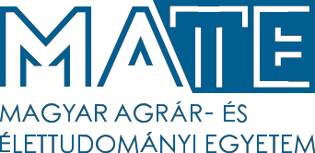
Hungarian University of Agriculture and Life Sciences Institute of Environmental Sciences, Research Center for Irrigation and Water Management and
Research Center for Fisheries and Aquaculture Hungary

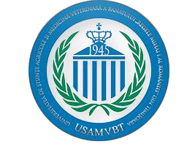
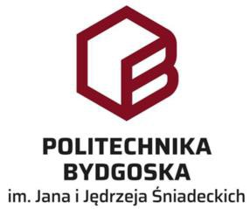
Co-organizing international institutions

Banat's University of Agricultural Sciences and Veterinary Medicine "King Michael I of Romania" from Timisoara Faculty of Agriculture and Faculty of Management and Rural Tourism
Romania

Bydgoszcz University of Science and Technology Faculty of Agriculture and Biotechnology
Poland

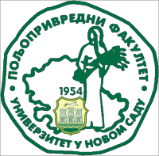
University of Novi Sad Faculty of Agriculture Serbia

cordially invite You and Your Colleagues.

The conference has been adapted to World Water Day (UN). The conference is an annual multidisciplinary platform for international scientific discussion on water in all respects. The event will contribute to the dissemination of knowledge and good practices. ISCW represents a good opportunity to exchange ideas, to strengthen and to create new academic networks, and to foster dialog between the academia, public institutions, the private sector and civil society organizations on the recent global and regional trends in water use.
5th ISCW will cover the following main thematic areas:
- community water supply and wastewater treatment
- water management
- water use in agriculture (irrigation, plant production, animal husbandry, fisheries and aquaculture)
- water use in food and drink industry
- environmental protection
- climate change and natural resources management
- rural development and agro-economy
- water tourism, sports and recreation

The official language of the conference will be ENGLISH. The conference will be organized in HYBRID way.
The participation at the conference is FREE (no registration fee), but registration is needed. Personal participation is possible by giving a presentation or presenting a poster. The registration covers the following:
- Full access to all Conference sessions
- Refreshments in breaks
- Lunches
- Diners
- Field trips during the conference

Important dates:
Registration and submission of abstract 20 February 2022
Submission of online posters 14 March 2022
Submission of full papers 22 March 2022
5th ISCW event 22-24 March 2022

Full papers will be published in the proceedings of the conference and selected papers will be published (free of charge) in COLUMELLA Journal of Agricultural and Environmental Sciences (http://www.columella.mkk.szie.hu/).

Venue:
Liget Wellness and Conference Hotel**** - Szarvas (ligetszarvas.hu)

Accommodation:
Participants are advised to book their accommodation in Liget Wellness and Conference Hotel or hotels listed later on conference website.

Preliminary program:
22nd March 2022 Registration
Opening Ceremony Plenary presentations Lunch
Sessions Dinner

23rd March 2022 Sessions
Lunch Field trip Dinner

24th March 2022 Visit to the Arboretum of Szarvas (optional)
Departure

CONTACT:
Website of the conference with more details is available: iscw.hu.
For any additional information please feel free to contact: info@iscw.hu
The registration form should be return also to this e-mail until 20. February 2022.

